NG ROADRACING CLUB
2025 OFFICIALS AVAILABILITY FORM
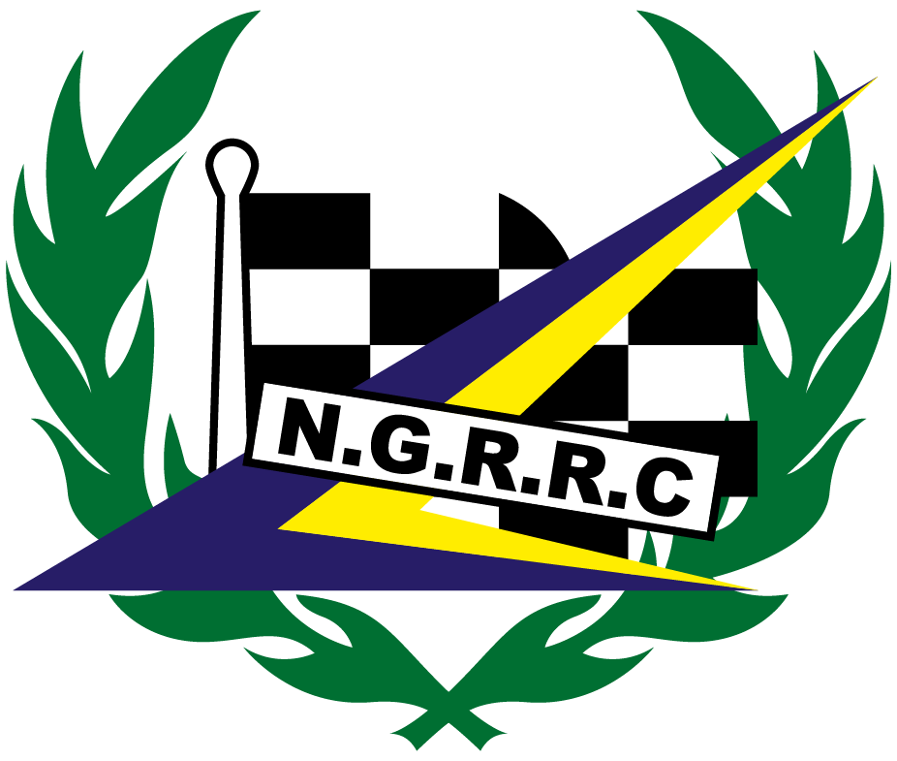

FIRST NAME: ____________________________ HOME # ___________________________

SURNAME: _____________________________ MOBILE # ____________________________

ADDRESS: ______________________________ EMAIL _____________________________

_______________________________________

_______________________________________ POST CODE: _____________________________

Next of Kin, Contact Name and Phone no. ________________________________________

Last Marshal training course attended. Date: ____________ Venue :___________________

If new (and therefore had no training) please simply state “NEW”

If you are a Technical Official, please tick here: _______

RACE DATES
PLEASE TICK BOXES FOR THOSE DATES YOU ARE AVAILABLE

DATES | VENUE | FRI | SAT | SUN
11th,12th &13th April | Cadwell Park
9th, 10th & 11th May | Snetterton 300
30th, 31st May & 1st June | Pembrey
27th, 28th & 29th June | Anglesey
18th, 19th & 20th July | Brands Hatch
15th, 16th & 17th Aug | Donington Park
12th & 13th Sept | Oulton
11th & 12 October | Castle Combe

You can complete this form and send it via email or post, or preferably simply email me with your availability.
Sue Collins
2 Sunhill Apartments, 19 Alta Vista Road
Paignton, Devon
TQ4 6DA
Mobile 07963 046243
Email ngchiefmarshal@outlook.com

DATA PROTECTION By completing and returning this form you are deemed to have given your permission for me to hold the personal information it contains and to contact you using post or email with information and passes for NGRRC events. I guarantee not use or share this information with any third party without first gaining your permission. I will only hold your information for as long as it is relevant, up to 3 years max. I will delete all your information from any records I keep immediately upon your request. Please contact me if you would like to further discuss how I hold your information.

